垂直活塞式 |  | 型号 | 直径 | 连接 | 控制 | 显示 | 输出信号 | 现场测量 | 最大压力 | 最大温度 | 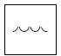  水 | 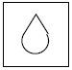  油 | 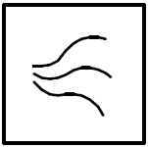  气体/空气 | 腐蚀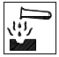 | 杂项
标准应用 | 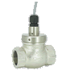 | FF | 8-40 | 黄铜母螺纹 |  |  |  |  | 200 | 110 |  | √ | √
标准应用 | 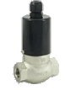 | FM | 8-15 | 青铜母螺纹 |  |  |  |  | 200 | 90 |  | √ | √
标准应用 | 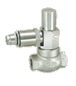 | G | 8-15 | 青铜母螺纹 |  |  |  |  | 16 | 80 |  | √ | √ |  | 
标准应用 | 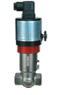 | VD | 8-80 | 青铜母螺纹 |  |  |  |  | 25 | 120 |  | √ | √ |  | 
标准应用 |  | VD | 8-50 | 不锈钢母螺纹 |  |  |  |  | 100 | 120 |  | √ | √ | √
标准应用 | 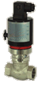 | VM | 8-80 | 青铜母螺纹 |  |  |  |  | 100 | 90 |  | √ | √
标准应用 |  | VM | 8-50 | 不锈钢母螺纹 |  |  |  |  | 100 | 90 |  | √ | √ | √
标准应用 | 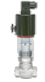 | VDO | 8-80 | 青铜母螺纹 |  |  |  |  | 100 | 120 |  | √ | √
标准应用 |  | MXR | 8-80 | 青铜母螺纹 |  |  |  |  | 100 | 160 |  | √ | √
标准应用 |  | MXO | 8-80 | 青铜母螺纹 |  |  |  |  | 100 | 160 |  | √ | √
标准应用 |  | MXM | 8-80 | 青铜母螺纹 |  |  |  |  | 100 | 160 |  | √ | √
标准应用 | 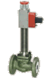 | TX | 15-200 | 铸钢法兰 |  |  |  |  | 40 | 350 |  | √ | √ |  | 
标准应用 | 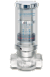 | MP | 8-80 | 青铜母螺纹 |  |  |  |  | 100 | 100 |  | √ | √
标准应用 | 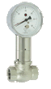 | TZ1 | 8-80 | 青铜母螺纹 |  |  |  |  | 100 | 90
标准应用 |  | TZ1 | 8-50 | 不锈钢母螺纹 |  |  |  |  | 100 | 90 |  | √ | √
标准应用 |  | TZ1 |  | 附加特征 |  |  |  |  |  |  |  |  |  | √
标准应用 | 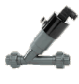 | PD | 8-80 | PVC胶粘 |  |  |  |  | 10 | 60 |  | √ | √ | √
标准应用 |  | PD | 8-50 | PVC Lue插口 |  |  |  |  | 10 | 60 |  | √ | √ | √
标准应用 |  | PD | 8-80 | PVC法兰 |  |  |  |  | 10 | 60 |  | √ | √ | √
特殊应用 |  | VD | 15-100 | 青铜法兰 |  |  |  |  | 16 | 120 |  | √ | √
特殊应用 |  | VD | 15-300 | 铸铁法兰 |  |  |  |  | 16 | 120 |  | √ | √
特殊应用 |  | VD | 15-300 | 铸钢法兰 |  |  |  |  | 40 | 120 |  | √ | √
特殊应用 |  | VD | 15-150 | 不锈钢法兰 |  |  |  |  | 40 | 120 |  | √ | √ | √
特殊应用 | 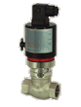 | VM | 15-200 | 铸铁法兰 |  |  |  |  | 16 | 90 |  | √ | √
特殊应用 | 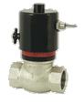 | VI | 8-80 | 青铜母螺纹 |  |  |  |  | 16 | 60 |  | √ | √
特殊应用 | 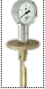 | TZ1 | 65-200 | 铸铁法兰 |  |  |  |  | 16 | 90 |  | √ | √

