挡板式 |  | 型号 | 直径 | 连接 | 控制 | 显示 | 输出信号 | 现场测量 | 最大压力 | 最大温度 | 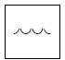  水 | 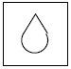  油 | 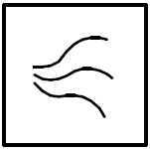  气体/空气 | 腐蚀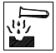 | 杂项
挡板 | 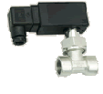 | UR3K  UMK3 | 10-50 | 黄铜母螺纹 |  |  |  |  | 25 | 110 |  | √ | √ |  | Honsberg连接系统  
 |  |  |  | 不锈钢母螺纹 |  |  |  |  | 25 | 110 |  | √ | √
挡板 |  | UR3K  UMK3 | 15-80 | 黄铜焊接管套 |  |  |  |  | 25 | 110 |  | √ | √
 |  |  |  | 不锈钢焊接管套 |  |  |  |  | 25 | 110 |  | √ | √
挡板 |  | UR3K  UMK3 | 10-50 | 黄铜母螺纹 |  |  |  |  | 25 | 110 |  | √ | √
 |  |  |  | 不锈钢母螺纹 |  |  |  |  | 25 | 110 |  | √ | √
挡板 |  | UR3K  UMK3 | 15-80 | 黄铜焊接管套 |  |  |  |  | 25 | 110 |  | √ | √
 |  |  |  | 不锈钢焊接管套 |  |  |  |  | 25 | 110 |  | √ | √
挡板 | 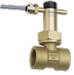 | UR1/  UR2 | 10-50 | 黄铜母螺纹 |  |  |  |  | 25 | 110 |  | √ | √
 |  |  |  | 不锈钢母螺纹 |  |  |  |  | 25 | 110 |  | √ | √
挡板 |  | UR1/  UR2 | 15-80 | 焊接管套 |  |  |  |  | 25 | 110 |  | √ | √
挡板 | 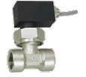 | U1 | 10-50 | 黄铜母螺纹 |  |  |  |  | 16 | 60 |  | √ | √
挡板 | 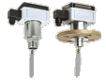 | UB1 | 25—  200 | 黄铜公螺纹 |  |  |  |  | 16 | 140 |  | √
 |  |  |  | 不锈钢公螺纹 |  |  |  |  | 16 | 140 |  | √ |  | √
挡板 |  | UB1 | 40—  200 | 黄铜法兰 |  |  |  |  | 16 | 140 |  | √
 |  |  |  | 不锈钢法兰 |  |  |  |  | 16 | 140 |  | √ |  | √
挡板 | 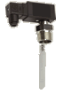 | CM2K | 25—  200 | 黄铜公螺纹 |  |  |  |  | 25 | 110 |  | √
 |  |  |  | 不锈钢公螺纹 |  |  |  |  | 25 | 110 |  | √
挡板 | 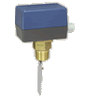 | CRG | 25—  200 | 黄铜公螺纹 |  |  |  |  | 11 | 110 |  | √ | YR |  | 
 |  |  |  | 不锈钢公螺纹 |  |  |  |  | 11 | 110 |  | √ |  | √
挡板 | 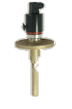 | VM | 40—  200 | 黄铜法兰 |  |  |  |  | 16 | 90 |  | √ | √
 |  |  |  | 不锈钢法兰 |  |  |  |  | 16 | 90 |  | √ | √
挡板 | 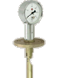 | TZ1 | 40—  100 | 黄铜法兰 |  |  |  |  | 16 | 90 |  |  | √
 |  |  |  | 不锈钢法兰 |  |  |  |  | 16 | 90 |  |  | √
挡板 | 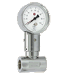 | UZ | 15-80 | 黄铜母螺纹 |  |  |  |  | 6 | 100 |  | √
 |  |  |  | 不锈钢母螺纹 |  |  |  |  | 6 | 100 |  | √ |  | √
动态翻板 | 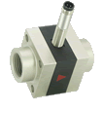 | XF | 8-20 | 黄铜母螺纹 |  |  |  |  | 16 | 70
 |  |  |  | 不锈钢母螺纹 |  |  |  |  | 16 | 70 |  |  |  | √
 |  |  |  | 塑料母螺纹 |  |  |  |  | 16 | 70

