直列活塞式 |  | 型号 | 直径 | 连接 | 控制 | 显示 | 输出信号 | 现场测量 | 最大压力 | 最大温度 | 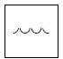  水 | 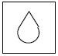  油 | 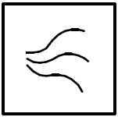  气体/空气 | 腐蚀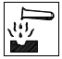 | 杂项
标准应用 | 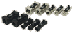 | FW1  FW3 | 8-25 | 黄铜母螺纹 |  |  |  |  | 10 | 90 |  | √ | √
标准应用 | 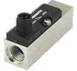 | FW1  FW3 | 8-25 | 塑料母螺纹 |  |  |  |  | 100 | 90 |  | √ | √
标准应用 |  | FW1  FW3 | 8 | 黄铜母螺纹 |  |  |  |  | 100 | 90 |  | √ | √
标准应用 | 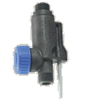 | FX | 15 | 黄铜公螺纹 |  |  |  |  | 10 | 80 |  |  | √
标准应用 | 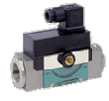 | HD1K  HD2K  HM1K | 8-25 | 黄铜母螺纹 |  |  |  |  | 200 | 120 |  | √ | √ |  |   
 |  |  |  | 不锈钢母螺纹 |  |  |  |  | 200 | 120 |  | √ | √ | √
标准应用 |  | HD1K  HD2K  HM1K | 8-25 | 黄铜母螺纹 |  |  |  |  | 200 | 120 |  |  | √
 |  |  |  | 不锈钢母螺纹 |  |  |  |  | 200 | 120 |  |  | √ | √
标准应用 |  | HD1K  HD2K  HM1K | 8-25 | 黄铜母螺纹 |  |  |  |  | 200 | 70 |  | √ | √
 |  |  |  | 不锈钢母螺纹 |  |  |  |  | 200 | 70 |  | √ | √ | √
标准应用 | 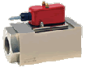 | HR1MV | 32-50 | 黄铜母螺纹 |  |  |  |  | 200 | 120 |  | √ | √
 |  |  |  | 黄铜母螺纹 |  |  |  |  | 200 | 120 |  | √ | √ | √
标准应用 | 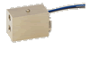 | MF | 3 | 黄铜母螺纹 |  |  |  |  | 6 | 80
标准应用 |  | MF | 7 | 黄铜母螺纹 |  |  |  |  | 6 | 80
标准应用 | 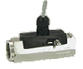 | MR | 8-25 | 黄铜母螺纹 |  |  |  |  | 200 | 120 |  | √ | √
 |  |  |  | 不锈钢母螺纹 |  |  |  |  | 200 | 120 |  | √ | √ | √
标准应用 | 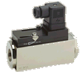 | MR1K | 8-25 | 黄铜母螺纹 |  |  |  |  | 200 | 120 |  | √ | √
 |  |  |  | 不锈钢母螺纹 |  |  |  |  | 200 | 120 |  | √ | √ | √
标准应用 |  | RVM | 8 | 黄铜母螺纹 |  |  |  |  | 300 | 100 |  |  | √
 |  |  |  | 不锈钢母螺纹 |  |  |  |  | 300 | 100 |  |  | √ | √
标准应用 | 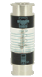 | NH1 | 15 | 不锈钢母螺纹 |  |  |  |  | 10 | 65
标准应用 | 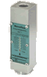 | NJ  NJV | 8-25 | 黄铜母螺纹 |  |  |  |  | 100 | 100 |  | √ | √
 |  |  |  | 不锈钢母螺纹 |  |  |  |  | 100 | 100 |  | √ | √ | √
标准应用 |  | NJ  NJV | 8-25 | 黄铜母螺纹 |  |  |  |  | 100 | 100 |  |  | √
标准应用 |  | MH | 8-25 | 铝母螺纹 |  |  |  |  | 10 | 65 |  | √ | √
标准应用 | 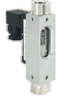 | VF | 8 | 黄铜母螺纹 |  |  |  |  | 16 | 100 |  | √ | √
 |  |  |  | 不锈钢母螺纹 |  |  |  |  | 16 | 100 |  | √ | √ | √
标准应用 | 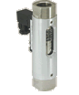 | VO | 15-25 | 黄铜母螺纹 |  |  |  |  | 16 | 100 |  | √ | √
 |  |  |  | 不锈钢母螺纹 |  |  |  |  | 16 | 100 |  | √ | √ | √
标准应用 | 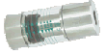 | NO | 8-25 | 黄铜母螺纹 |  |  |  |  | 50 | 90 |  | √ | √
 |  |  |  | 不锈钢母螺纹 |  |  |  |  | 50 | 90 |  | √ | √ | √
特殊应用 |  | AR | 10 | 青铜母螺纹 |  |  |  |  | 150 | 80 |  | √ | √
特殊应用 | 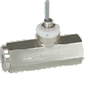 | MI | 8-25 | 青铜母螺纹 |  |  |  |  | 16 | 60 |  | √ | √
 |  |  |  | 不锈钢母螺纹 |  |  |  |  | 16 | 60 |  | √ | √ | √
特殊应用 | 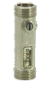 | OT | 15-20 | 青铜公螺纹 |  |  |  |  | 10 | 100 |  | √ | √

